**Problem Statement**

You are developing a card game for 4 players. The game requires only one deck of unique cards as shown below:

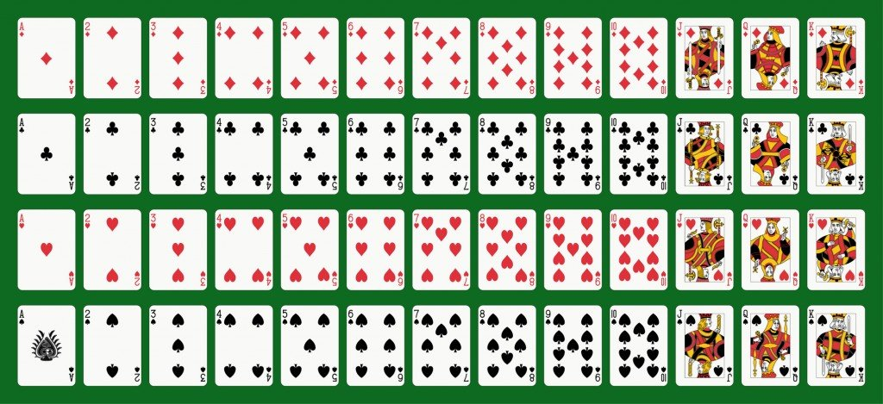

Photo Credit: Mannaggia / Fotolia

The deck of 52 card has 4 suits from top to bottom: diamonds (D), clubs (C), hearts (H), and spades (S). Each card has a point as shown in the table below.

|  |  |
| --- | --- |
| Face | Point |
| Ace/A | 1 |
| 2 | 2 |
| 3 | 3 |
| 4 | 4 |
| 5 | 5 |
| 6 | 6 |
| 7 | 7 |
| 8 | 8 |
| 9 | 9 |
| 10 | 0 |
| Jack/J | 0 |
| Queen/Q | 0 |
| King/K | 0 |

The 52 cards are shuffled at the beginning of a game. A game has many rounds. In each round, each player is given 3 cards based on a sequence of one card per player. The sum of cards for each player is calculated. The player(s) with the highest rightmost digit in the sum wins that particular round. The game will end when there are insufficient cards to continue to next round. The player with the highest win count wins the game.

Sample run:

Win count: P1 = 0 P2 = 0 P3 = 0 P4 = 0

Available cards: C5 S6 SK DA CK D4 H7 C4 CQ SA CA D10 H6 DQ D9 H5 H3 DJ D8 S7 D5 S3 D3 H2 H8 C8 H9 HQ SQ CJ C10 C2 H4 HA D2 C9 HK D6 SJ S10 DK C6 S9 S4 C7 HJ H10 S2 S8 D7 S5 C3

Used cards:

C:

D:

H:

S:

Press ENTER to deal cards...

ROUND 1:

P1 cards: C3 S2 S4 | Sum = 9 | Winner

P2 cards: S5 H10 S9 | Sum = 4

P3 cards: D7 HJ C6 | Sum = 3

P4 cards: S8 C7 DK | Sum = 5

Win count: P1 = 1 P2 = 0 P3 = 0 P4 = 0

Available cards: C5 S6 SK DA CK D4 H7 C4 CQ SA CA D10 H6 DQ D9 H5 H3 DJ D8 S7 D5 S3 D3 H2 H8 C8 H9 HQ SQ CJ C10 C2 H4 HA D2 C9 HK D6 SJ S10

Used cards:

C: 3 6 7

D: 7 K

H: 10 J

S: 2 4 5 9 8

Press ENTER to deal cards...

ROUND 2:

P1 cards: S10 C9 C2 | Sum = 1

P2 cards: SJ D2 C10 | Sum = 2

P3 cards: D6 HA CJ | Sum = 7 | Winner

P4 cards: HK H4 SQ | Sum = 4

Win count: P1 = 1 P2 = 0 P3 = 1 P4 = 0

Available cards: C5 S6 SK DA CK D4 H7 C4 CQ SA CA D10 H6 DQ D9 H5 H3 DJ D8 S7 D5 S3 D3 H2 H8 C8 H9 HQ

Used cards:

C: 3 6 7 9 2 10 J

D: 7 K 2 6

H: 10 J A K 4

S: 2 4 5 9 8 10 J Q

Press ENTER to deal cards...

ROUND 3:

P1 cards: HQ H2 S7 | Sum = 9 | Winner

P2 cards: H9 D3 D8 | Sum = 0

P3 cards: C8 S3 DJ | Sum = 1

P4 cards: H8 D5 H3 | Sum = 6

Win count: P1 = 2 P2 = 0 P3 = 1 P4 = 0

Available cards: C5 S6 SK DA CK D4 H7 C4 CQ SA CA D10 H6 DQ D9 H5

Used cards:

C: 3 6 7 9 2 10 J 8

D: 7 K 2 6 3 8 J 5

H: 10 J A K 4 Q 2 9 8 3

S: 2 4 5 9 8 10 J Q 7 3

Press ENTER to deal cards...

ROUND 4:

P1 cards: H5 D10 C4 | Sum = 9 | Winner

P2 cards: D9 CA H7 | Sum = 7

P3 cards: DQ SA D4 | Sum = 5

P4 cards: H6 CQ CK | Sum = 6

Win count: P1 = 3 P2 = 0 P3 = 1 P4 = 0

Available cards: C5 S6 SK DA

Used cards:

C: 3 6 7 9 2 10 J 8 4 A Q K

D: 7 K 2 6 3 8 J 5 10 9 Q 4

H: 10 J A K 4 Q 2 9 8 3 5 7 6

S: 2 4 5 9 8 10 J Q 7 3 A

P1 wins this game! Congrats!

Press Q to quit the game. Press N to start a new game…